**EEE361**

**ASSIGNMENT**

**SET-10**

1. The integral

$$a=\int_{S}{da}$$

Is sometimes called the vector area of the surface S. If S happens to be flat then |a| is the scaler area, obviously.

a. Show that a = 0 for any closed surface.

b. show that a is the same for all surfaces sharing the same boundary.

c. Show that $a= \frac{1}{2} \oint{r × dl}$ where the integral is around the boundary line. [Hint: one way to do it is to draw the cone subtended by the loop at the origin. Divide the conical surface up into infinitesimal triangular wedges, each with vertex at the origin and opposite side **dl**, and exploit the geometrical interpretation of the cross product.

1. In free space $E=20Cos\left(ωt-50x\right)$ ay V/m, Find:
2. Jd
3. H
$ω$

4. If any EM field fails to satisfy Maxwell’s Equation and the wave equation derived from them, then that is said to be nonexistent or not Maxwellian. Suppose the following expressions exist in charge free-regions. Find weather they are Maxwellian or not? State why the expression/s are not Maxwellian. (Show Calculation)
$A = 40 sin (ωt + 10x) a_{z}$

$B = \frac{10}{ρ} cos (ωt - 2ρ) a_{∅}$

$C = ( 3 ρ^{2} cot ∅a_{p} + \frac{cos ∅}{ρ} a_{∅}) sin ωt$

$D = \frac{1}{r} sinθ sin(ωt - 5r) a_{∅}$

5. An expression for an electric field is given below

$E=20Cos\left(ωt-2x-3z\right)$ ay V/m

Is incident on a dielectric slab (Z ≥ 0) With µr = 1.0 and εr = 2.5 Find:

1. The polarization of the wave
2. The angle of incidence
3. The reflected E and H field
4. The transmitted E and H field

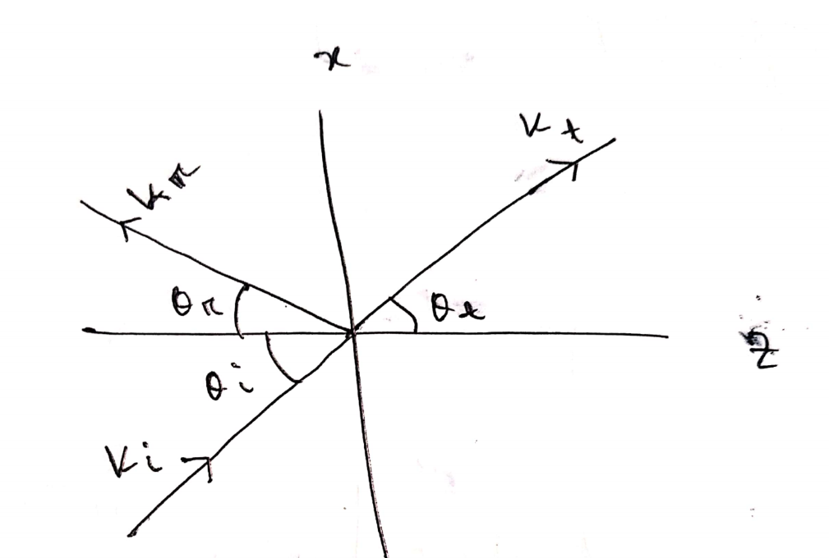

Fig: Problem 4

1. Identify weather these functions satisfy the wave equations or not. Show all the calculations.

$50e^{jω\left(t-3z\right)}$

$sinω (10z + 5t)$

${ (x + 2t)}^{2}$

$\cos^{2}(y+5t)$

$sin x cos t$

$cos (5v + 2x)$